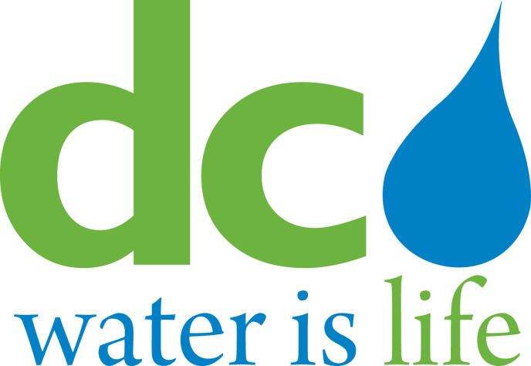

District of Columbia
Water and Sewer Authority

Board of Directors

Environmental Quality and Sewerage Services Committee
Thursday, January 15, 2015

9:30 a.m.

MEETING MINUTES

Committee Members Present DC Water Staff Present
Howard Gibbs, Acting Chairperson George Hawkins, General Manager
David Lake Len Benson, Chief Engineer
James Patteson Randy Hayman, General Counsel
Matthew Brown Linda Manley, Secretary to the Board
Adam Ortiz

- Call to Order

Mr. Howard Gibbs, Acting Chairperson, called the meeting to order at 9:30 AM.

AWTP Status Updates

BPAWTP Performance

Mr. Walt Bailey, Assistant General Manager for Wastewater Treatment, reported that the monthly average influent flow was 293 MGD, bringing the 12-month average to 300 MGD. 3.5-inches of precipitation fell during the December reporting period.

Biosolids production was 809 wet tons per day, compared with the annual average production of 1081 wet tons per day. Total nitrogen concentration averaged 4.6 mg/l for the month, and the annual average of 4.1 mg/l remains below the permit threshold. Overall, plant performance was excellent, with 100% permit compliance.

Mr. Bailey informed the Committee that the Enhanced Nitrogen Removal Facility projects have been completed and placed in-service including the Methanol Facility. The committee asked Mr. Bailey about the “demonstrations” of the new facilities such as the Methanol Facility and whether that meant leak detection and water testing. Mr. Bailey explained that as part of the construction contract, the contractor must test/demonstrate all equipment and piping to the prescribed pressure to locate any leaks before introducing methanol, for example, into the new Methanol Facility. Mr. Bailey further noted that the Department of Environment (DDOE) permit requires annual leak detection inspection for volatile organic carbon (VOC) of each joint in the Methanol Facility.
The commissioning of the digesters continues with approximately 60% of the biosolids going through the new thermal hydrolysis (Cambi) process and digesters and 40% of biosolids processed by centrifuge and lime stabilization. 100% digestion of the biosolids is expected late-February 2015. Mr. Bailey noted the Combined Heat and Power (CHP) contractor, Pepco Energy Services, is behind schedule and has had to bring temporary boilers to provide steam for the Cambi Thermal Hydrolysis process, which resulted in delays in feeding the digesters.

The committee requested Mr. Bailey work with the Chairman to setup a tour in Spring 2015 for the entire Board of Directors and committee members to see the progress made since their last tour that occurred during mid-construction of the Main Process Train. The committee asked for an overview/high level understanding of the contractual requirements for the Main Process Train facilities. Mr. Bailey explained that for each job, the Mechanical Completion triggers the start of the Operation Demonstration and performance testing. The Main Process Train consist of Screening, Pre-Dewatering, Cambi, and Digestion which have twenty-nine (29) performance goals that must be met; for example, volatile solids destruction in the digesters and meeting Class A biosolids requirements.

The committee commented that the average daily hauling bar chart by contractors shows a decline in the hauling quantity and asked whether this is attributed to the new digesters, and inquired if the bar chart can distinguish between digested- and lime-stabilized biosolids. Mr. Bailey commented that by March 2015 100% biosolids will be digested therefore we will not need the charts revised. Mr. Bailey noted that the existing lime stabilization system will be maintained and periodically exercised to be used as a backup system to handle peaks and emergencies.

updates: potomac interceptor sewer

1. Odor Abatement Project

Ms. Liliana Maldonado, Director of Engineering and Technical Services (DETS), reported that construction continues at both Virginia sites with Site 31 (Fairfax) at 80% complete, however, final completion is pending Dominion Virginia Power installation of permanent power. Committee Member James Patteson from Fairfax County, offered assistance via the Fairfax County liaison with Dominion Virginia Power to help direct DC Water staff to the appropriate party to expedite the permanent power installation at Site 31 (Fairfax). Ms. Maldonado welcomed the assistance and will follow-up with the Fairfax liaison. Site 46 (Loudoun) is 94% complete with punch list items remaining. Site 46 operational demonstration is expected to start in early February 2015. The committee commented that the odor control projects have been an interest of theirs and expressed concerns with the projects moving forward and continuing to encounter more delays. The committee further commented that the monthly reports are fairly repetitive and the committee wants to understand whether the project issues will be resolved shortly. Ms. Maldonado emphasized her priority to complete the projects before the summer “odor” season.

IV. ACTION ITEM - JOINT USE

1. Contract No. DCFA#468-WSA, Arcadis US, Inc.

ACTION ITEM – NON-JOINT USE

2. Contract No. 100180, Environmental Quality Resources, LLC

Mr. Len Benson, Chief Engineer, presented the two action items.

Action Item 1 is a request to execute an Engineering Services Agreement for Contract No. DCFA#468-WSA. The contract is to provide sewer program management and engineering services for assessing, rehabilitating, upgrading and improving the sanitary, combined sewer and storm water conveyance systems. Mr. Benson noted that a significant amount of work on the sewer system requires cleaning, CCTV inspection, examining video and determining what rehabilitation/repairs are necessary. The contract therefore includes about $6-$8M if DC Water elects to perform the work under this contract. The committee inquired if such work would be a supplement or is it part of the contract. Mr. Benson confirmed that it is part of this $42 million contract.

Mr. Benson explained that work for the next 5 years for the individual facilities has not been planned at this time in sufficient detail to allocate the jurisdictional user shares. The user shares will be allocated accordingly through the IMA Regional Committee and Technical Sub-Committee MJUF methodology as agreed in the 2012 IMA. The committee asked if Arcadis was previously Malcolm Pirnie with Mr. Benson responding that Malcolm Pirnie was one the firms acquired by Arcadis. The committee asked if suburban participation was involved in the review of the short listed firms. Mr. Benson responded that Nick Garner (WSSC) and Michael McGrath (Fairfax) were on the selection panel.

Action Item 2 is a request to execute a contract to rehabilitate and restore the Pope Branch Stream. The contract is to protect existing sewer assets running parallel and in the stream. Mr. Benson noted the sensitivity of the project due to the sewer running parallel and in some locations running in the stream and exposed manholes on the stream banks. The committee asked Mr. Benson to explain the rationale of why minority participation or local small businesses was not possible “due the specialized nature of the work”. Mr. Benson responded that working in the stream bed and banks requires considerable sensitivity by the contractor to limit the sediment discharge into the stream; therefore, the Engineering Team selected the firm that submitted the low bid and had significant experience in stream restoration and sewer construction (instead of the typical sewer contractor with limited stream bed experience). The committee asked if besides the primary stream restoration work, a minority firm could provide some portion of the work such as concrete headwalls. Mr. Benson responded that he will investigate the question further, and will be more cognizant of minority participation opportunities in future contracts. The committee requested additional clarification on the selected contractor’s qualifications. Mr. Benson deferred the question to Mr. William Elledge,,DETS, who responded that the contractor’s references were verified and that the firm had worked with multiple municipalities in Maryland, had also worked with DC Department of Environment, and responses from the references/owners were positive. Mr. Elledge also noted that the firm specializes in stream restoration and erosion and sediment control.

The Committee will recommend all action items to the Board for action.

V. OTHER BUSINESS/EMERGING ISSUES

The committee asked for an update on the Asset Management Program status and what are the established goals for the program. Mr. Benson requested for the update to be provided in a future committee meeting.

IX: ADJOURNMENT

The meeting was adjourned at 10:00am.

Follow-up Items

- Schedule a tour in spring 2015 of the MPT and CHP Facilities for the BOD. Provide a status update on the Asset Management Program at a future EQSS committee meeting.

